**With Isolation**

**My Permits –** This includes permits that you own and are responsible for.

**Dept Permits –** Permits owned by the department, but still under your purview.

**Open Permits –** Permits that are in progress, meaning they haven’t been completed yet.

**Closed Permits –** Permits that have been completed and are now closed.

**Step 1**

Requestor must fill out all the mandatory fields before submitting the permit request. If any required field is left blank, the system will display an error message, alerting the requestor to complete all mandatory inputs.

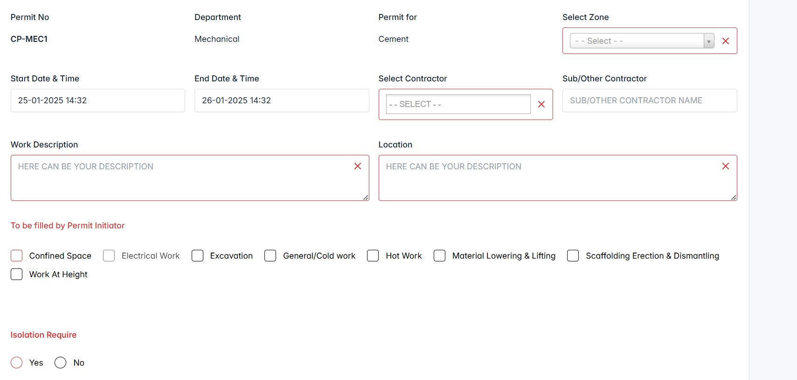

When the permit needs “**Isolation**”, please choose isolation as “**Yes**”. We mapped the equipment based on the selected zone in the same permit form. If the zone could not mapped none of any equipment’s, then you will get “**Others**” option only in the dropdown. Here is the sample for mapped equipment’s with “Clinker Loading” zone.

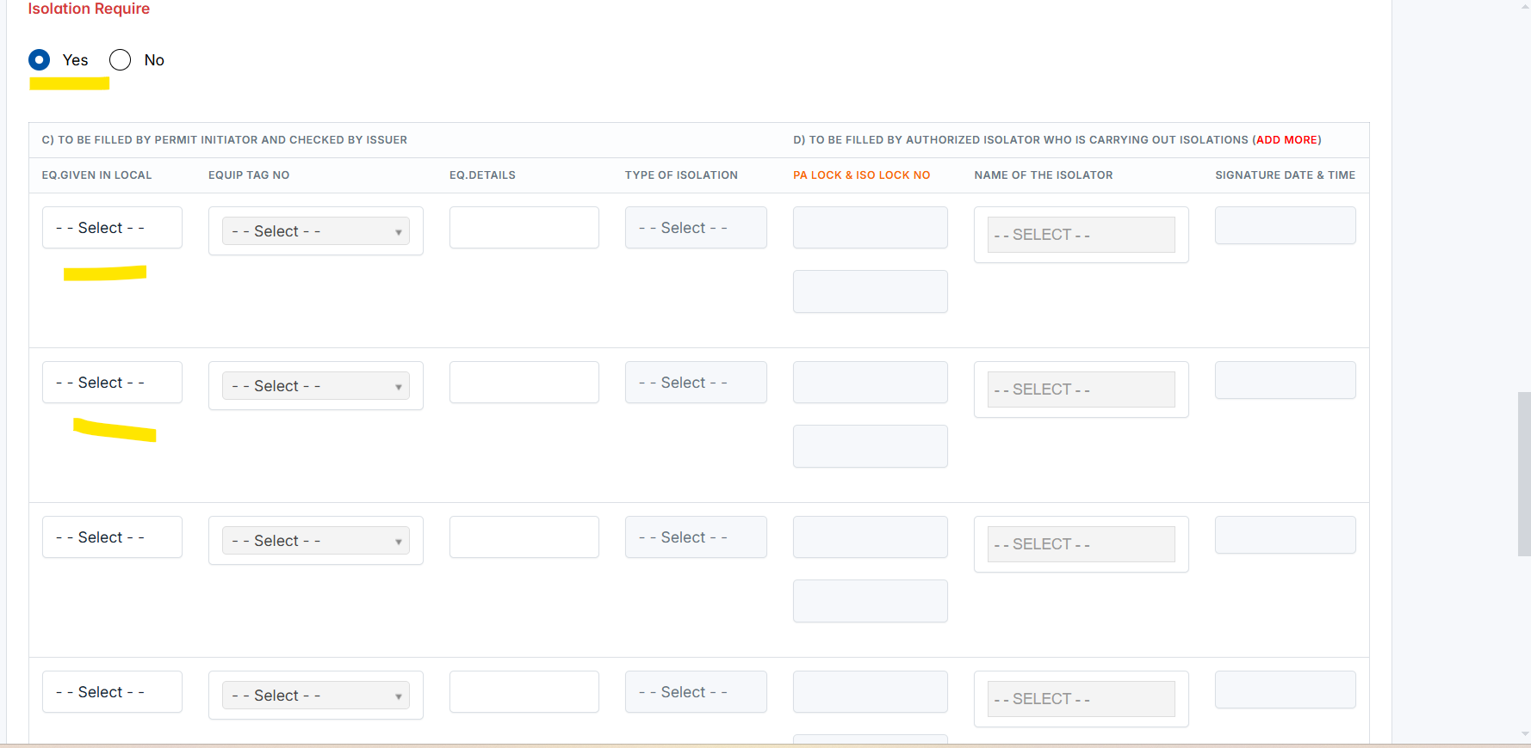

If none of the equipment is mapped to the zone "**AFR**," then based on your process, the only option available in the dropdown would be "Others." This means there wouldn't be a specific piece of equipment linked to that zone.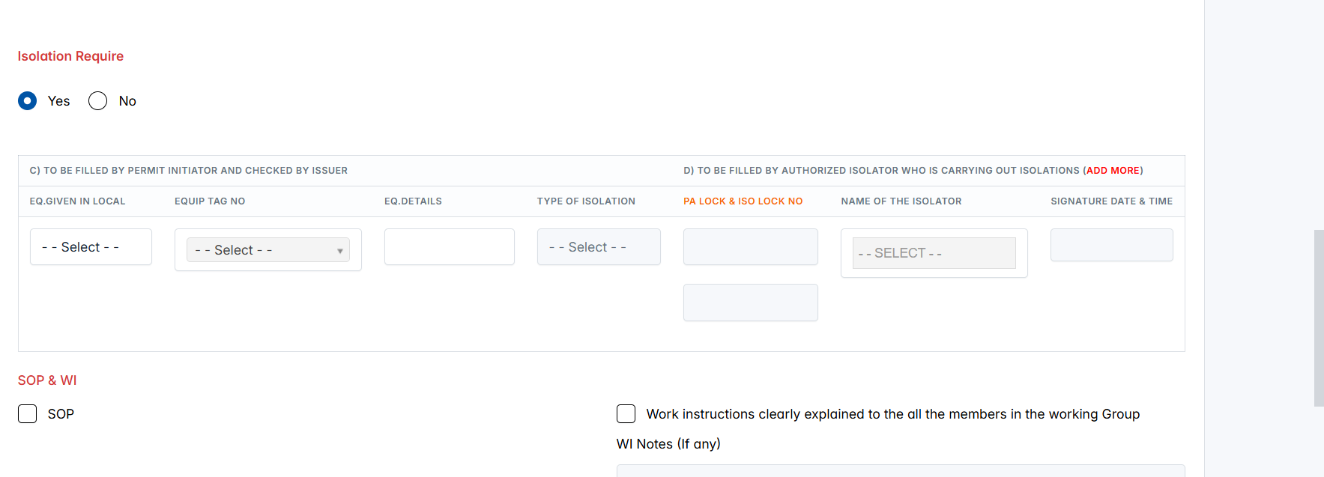

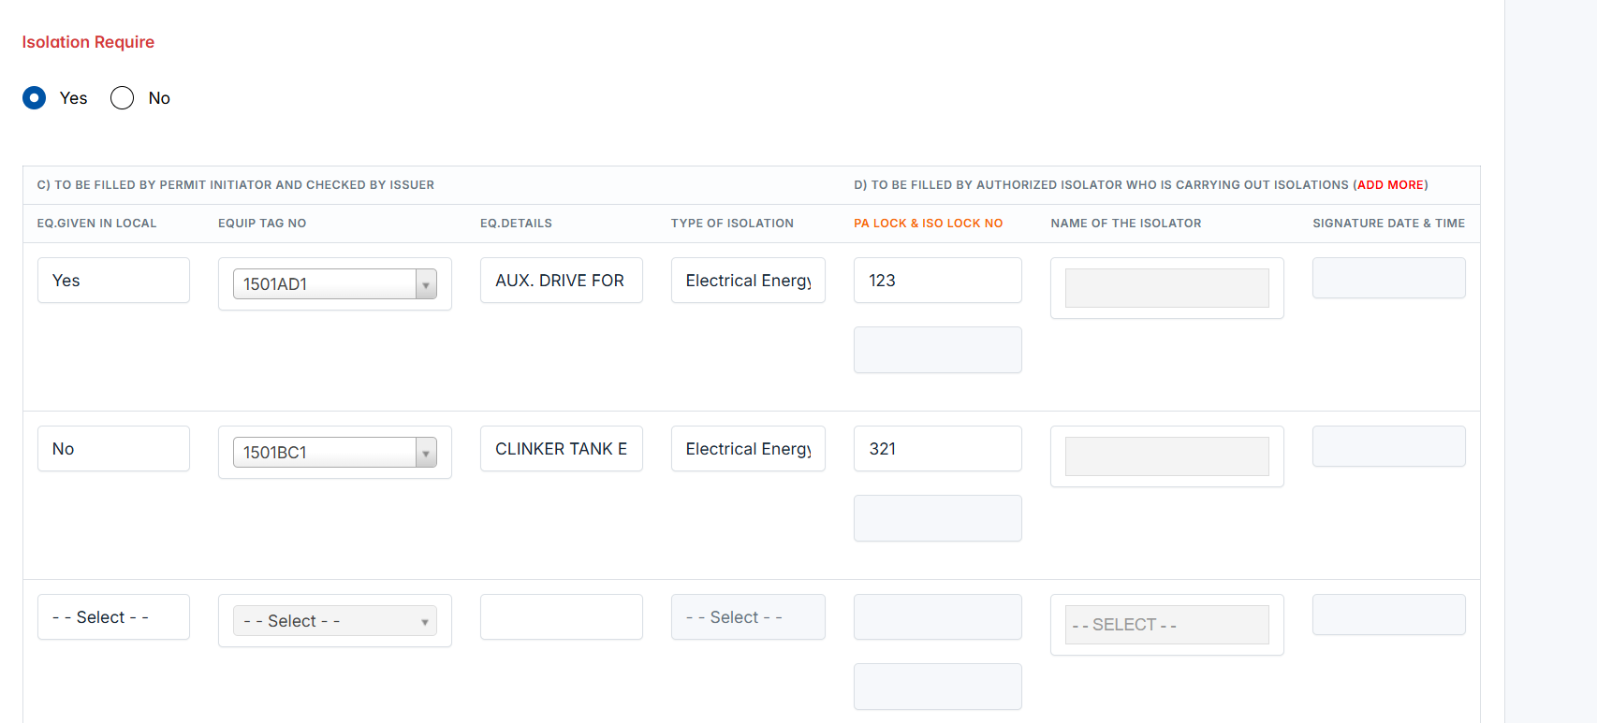

Initiated the new permit successfully. It’s started to listing under “My Permits”. Status is changed to “**Waiting Custodian/HOD Approval**”. Initiator can edit the permit info until the Custodian/HOD approve the permit.

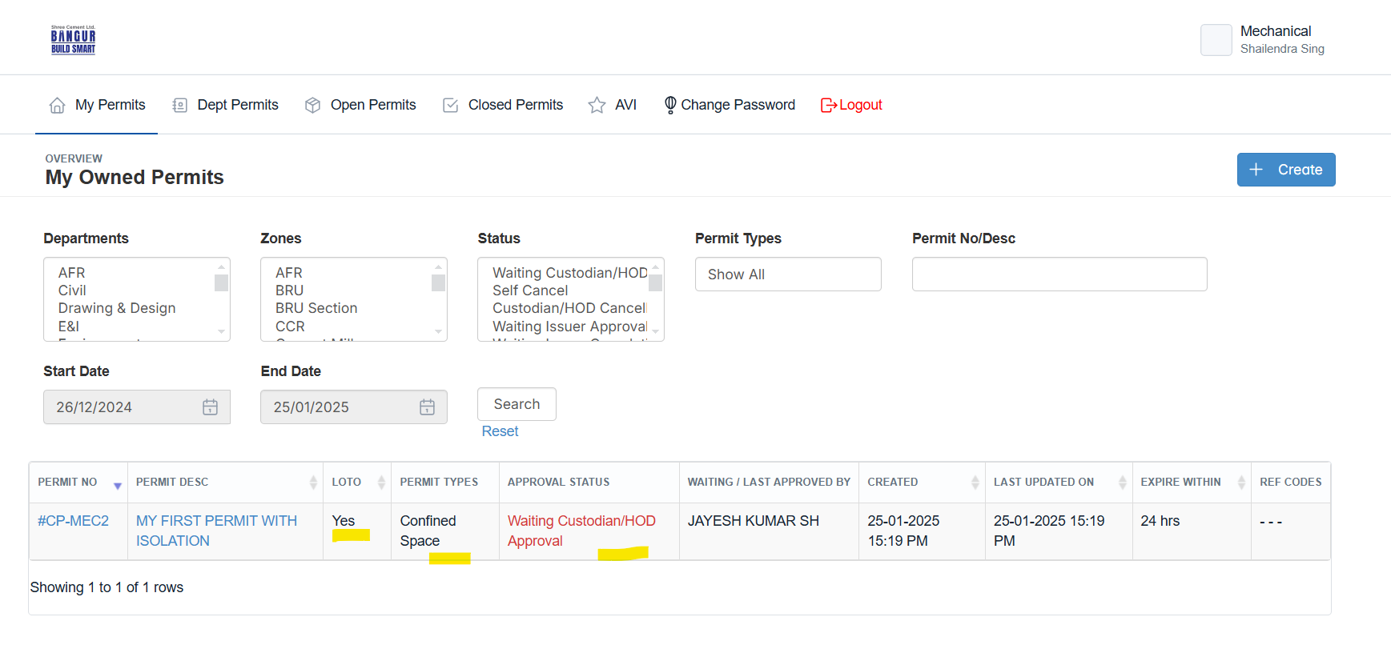

If, initiator won’t like to continue the permit, they can cancel the permit before getting approval from “Custodian/HOD”

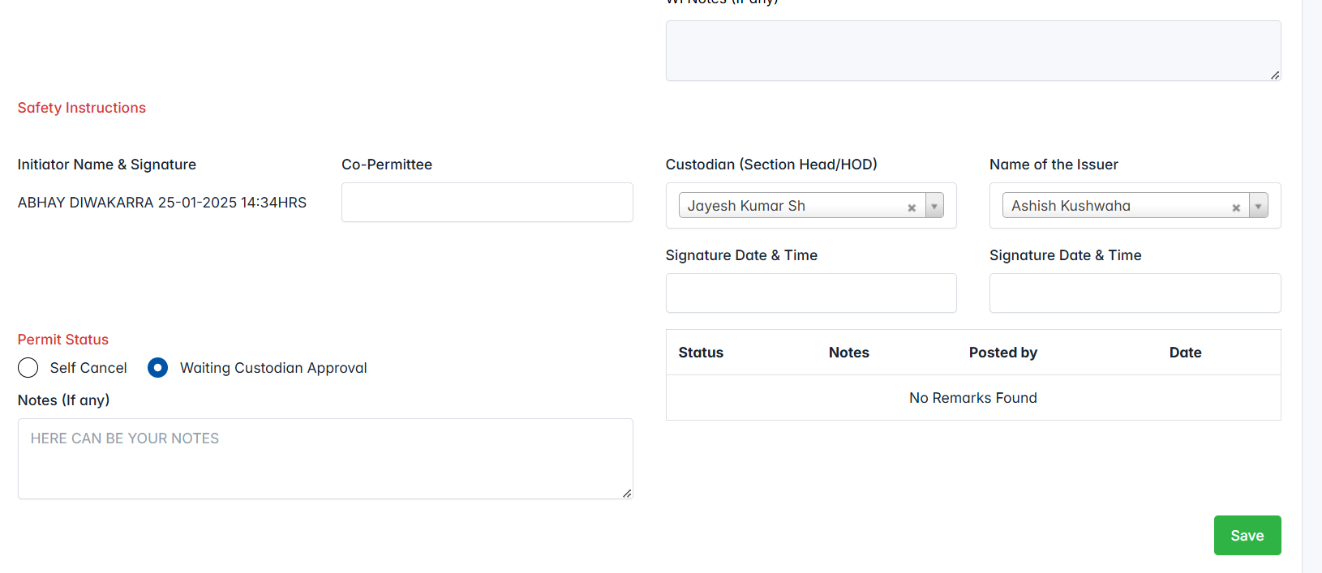

**Step 2 Responsible Person : Custodian/HOD**

Logged as Custodian/HOD and reviewing the permit. Now, Custodian approved the permit. Status is changed to “**Waiting Issuer Approval**”.

**Reopen –** This seems to mean that the permit is being sent back to the initiator for further action or clarification.

**Cancel** – The custodian is withdrawing or canceling the permit for some reason, possibly due to changes or issues with the request.  
  
**Approve** – The permit is moving forward to the issuer for final approval.

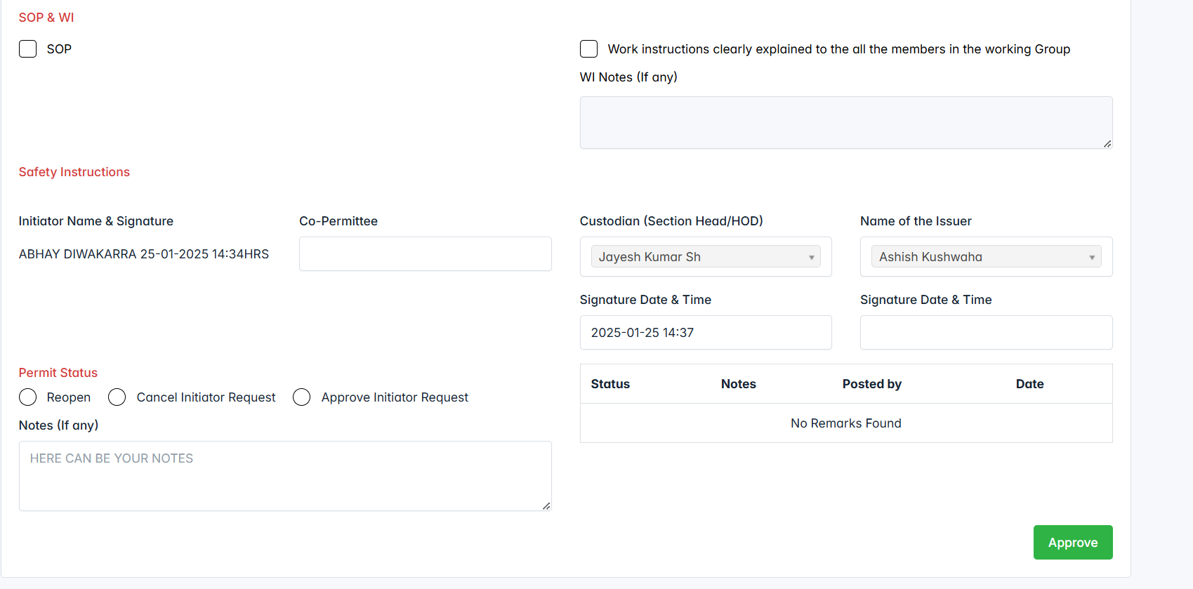

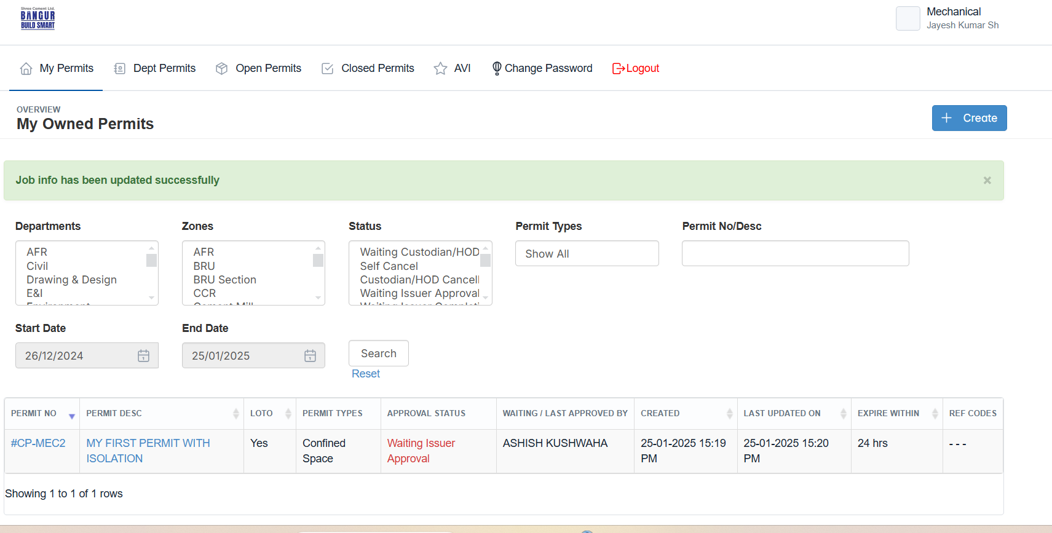

**Step 3 Responsible Person : Issuer**

Logged as “Issuer” and started the permit info.

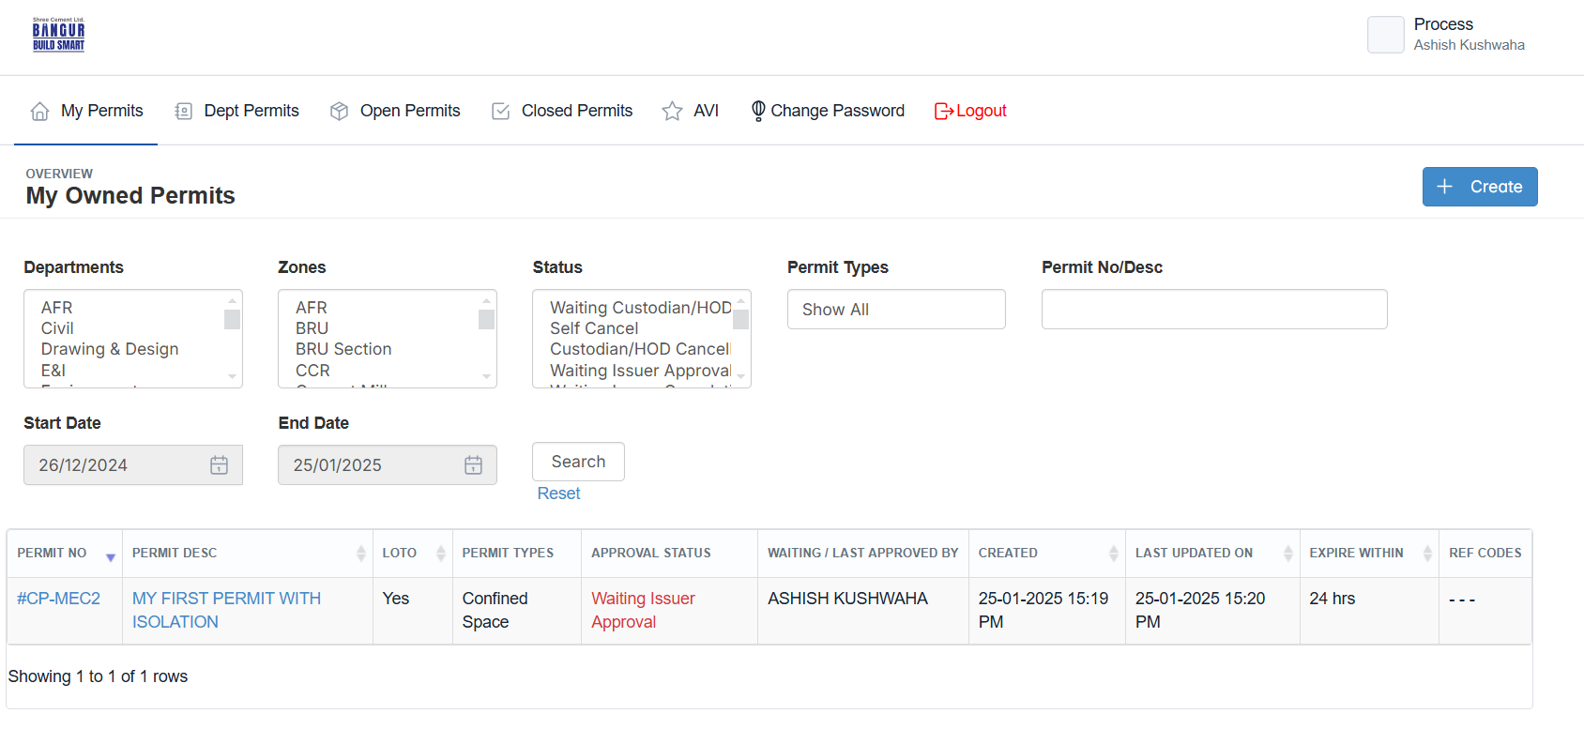

Issuer has the ability to either approve, cancel, or reopen a permit. When the permit is approved, it moves forward to the next step(**Final Submit**) in the process, and if not approved, it is sent back for revisions or further review. **Issuer must to be filled the isolators when the permit type is “Isolation”. They can choose more isolators to each equipments.**

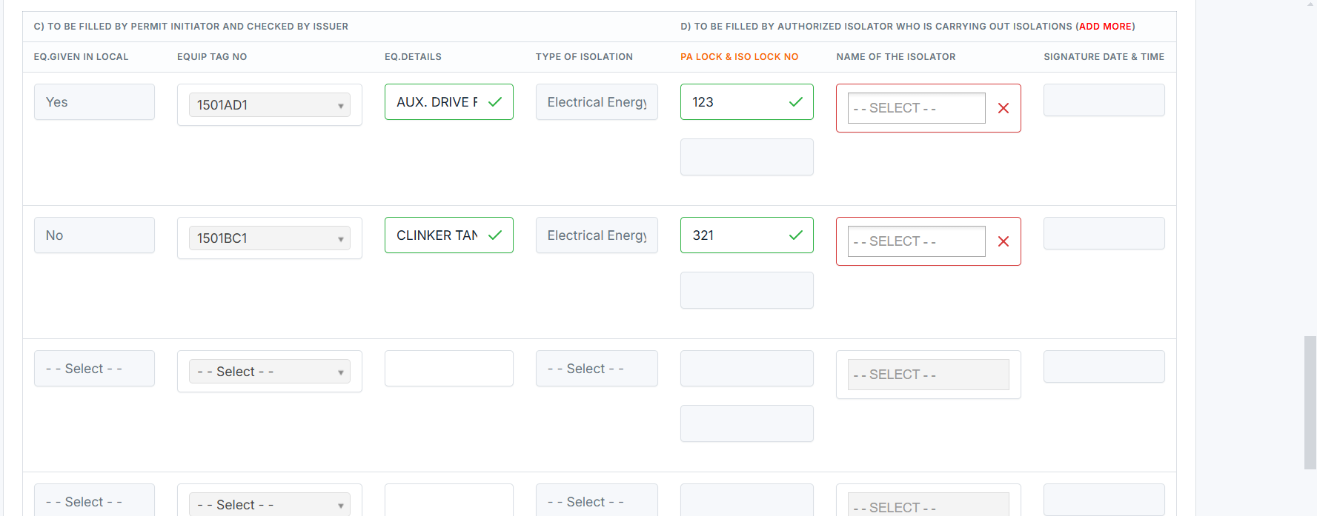

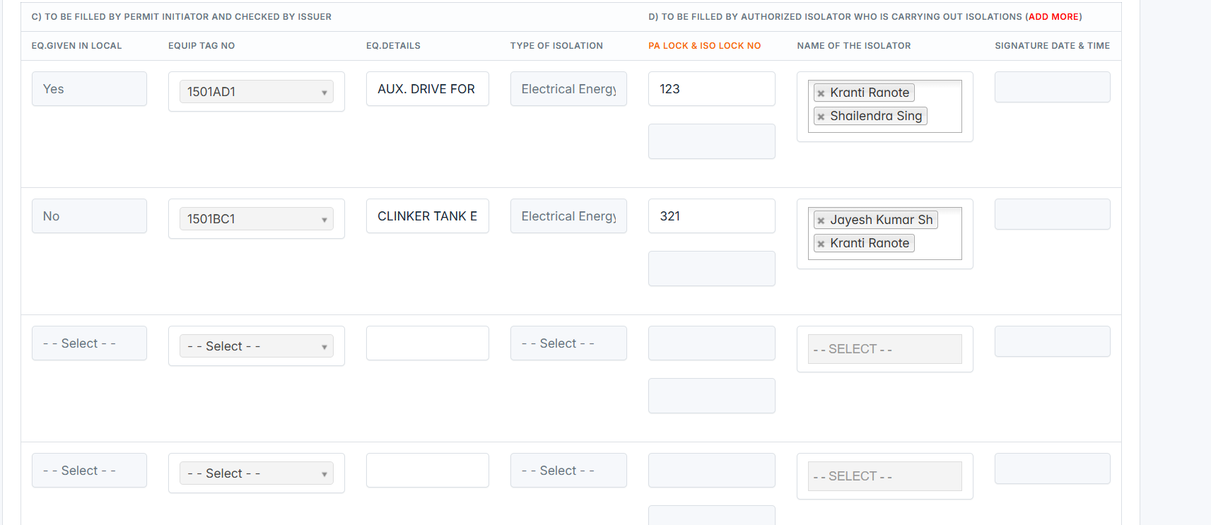

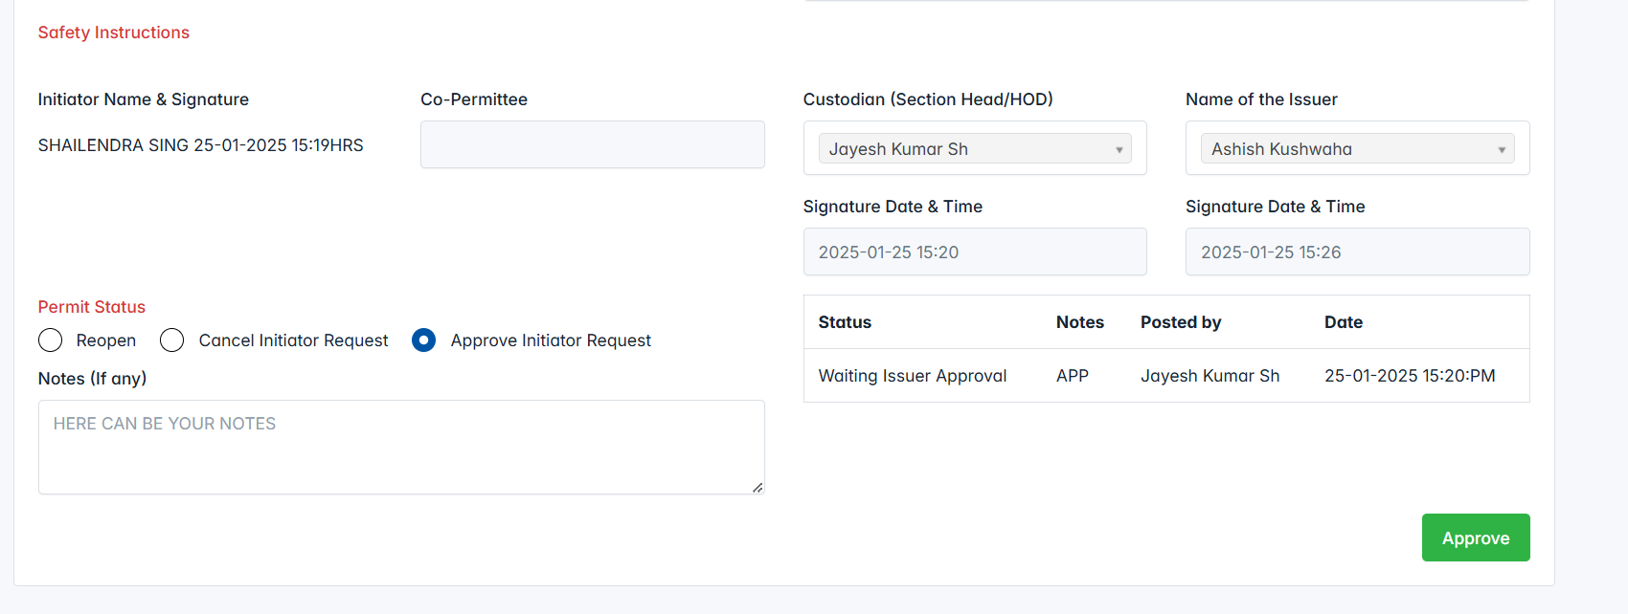

**After approved by Issuer, approval requests will be sent to the “Isolators” and status is changed to “Waiting Isolators Approval”.**

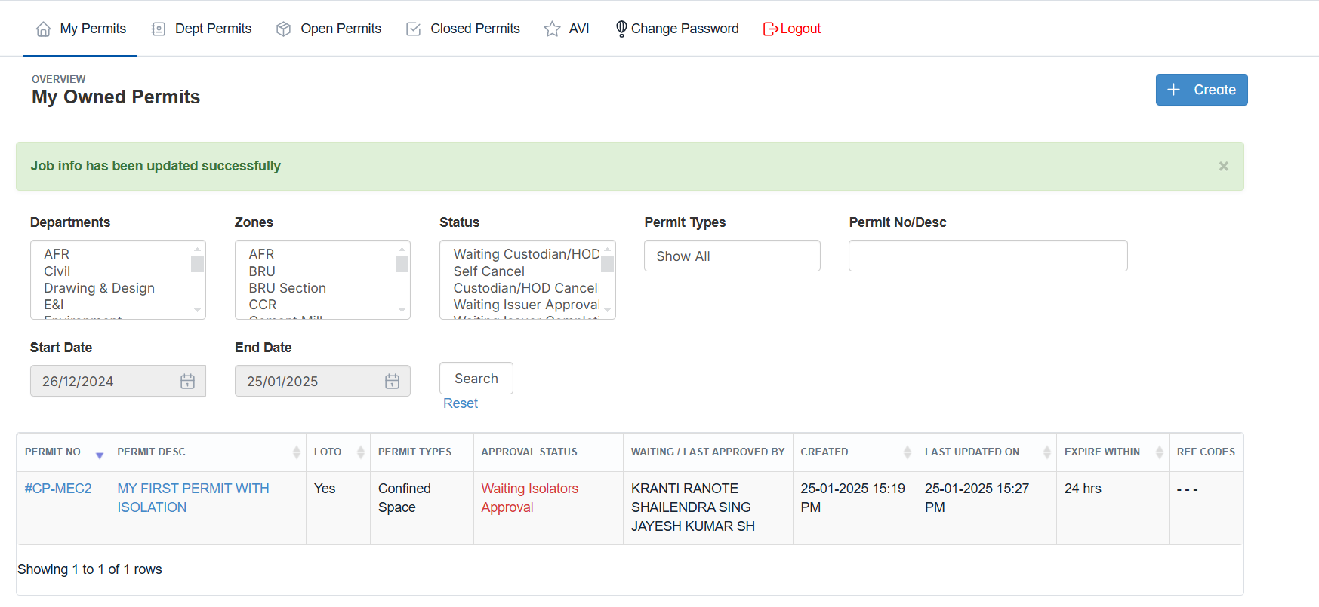

**Step4 Responsible Person : Isolators**

When you're logged as an isolator and performing the approval request for the permit, it's crucial to ensure that the correct TAG number of the equipment is filled in. The TAG number typically identifies the specific equipment being isolated or worked on, ensuring clear communication and safety during the isolation process.

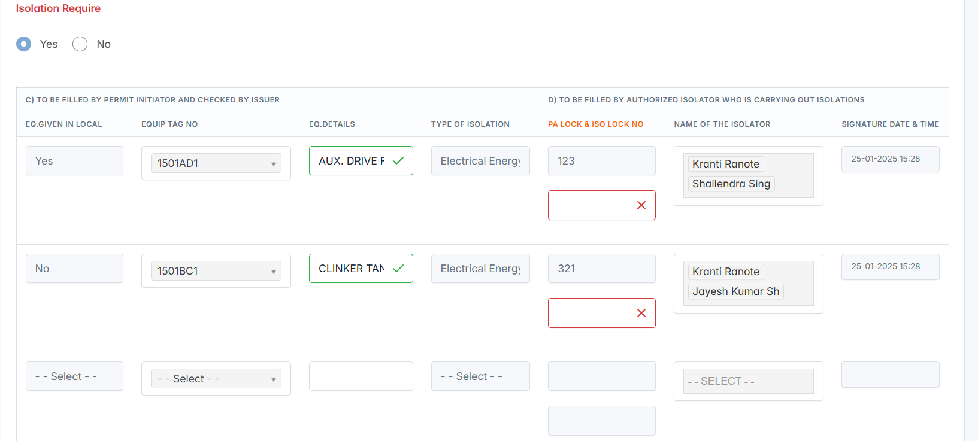

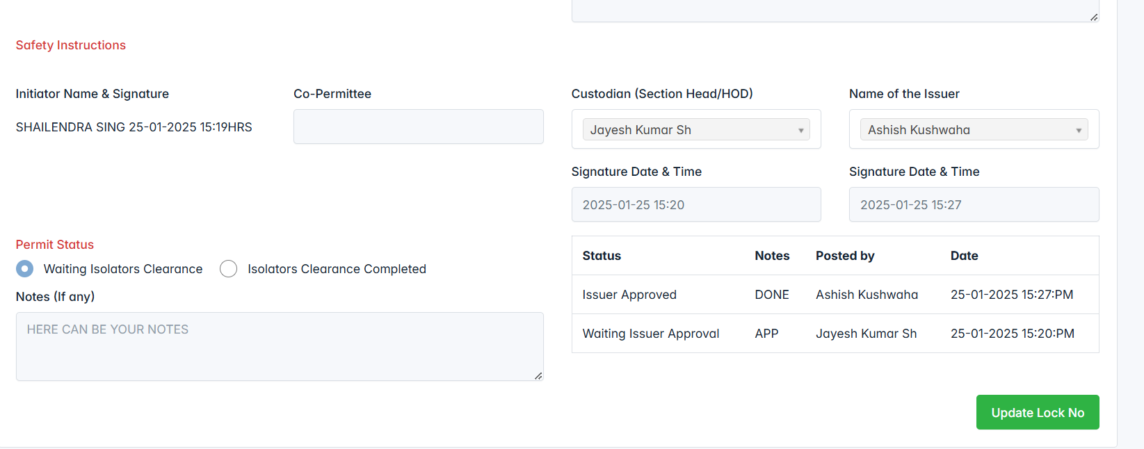

Once, all the isolators filled the TAG numbers to the equipment’s, permit status will be changed to “Waiting CCR Info”.

**Step5 Responsible Person : Initiator**

Requestor will be confirm they received the key or not.

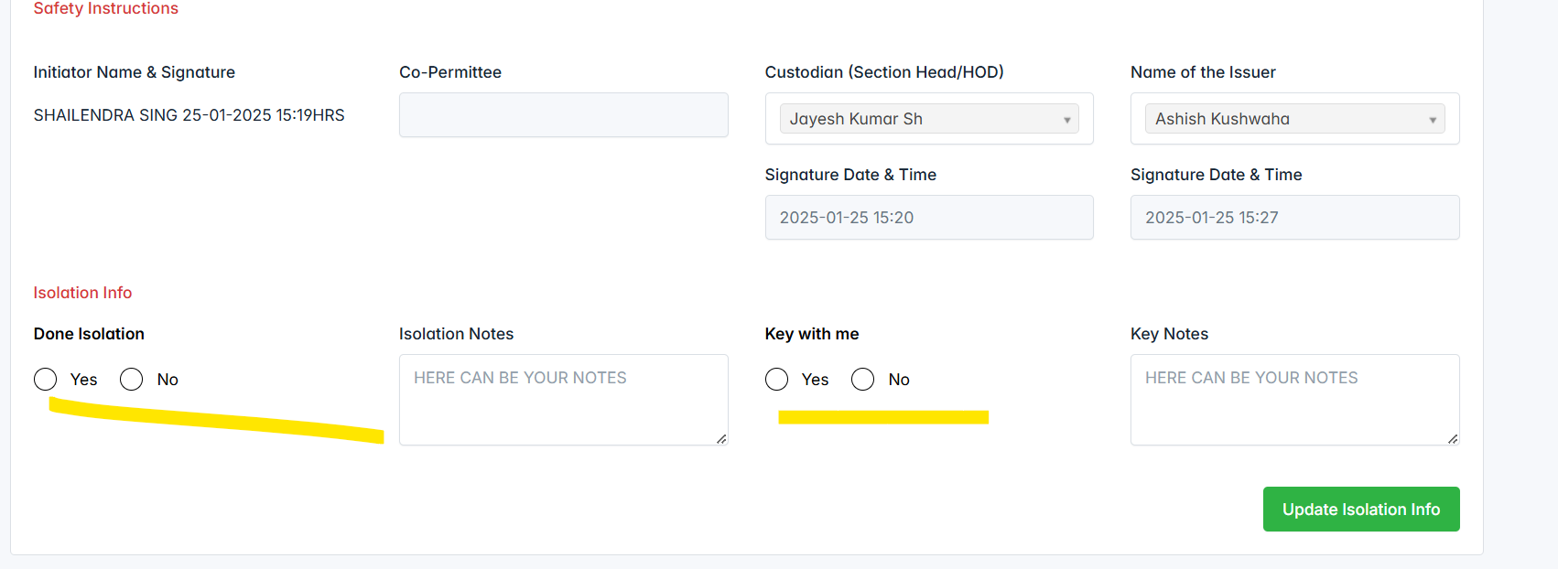

If they marked Key with me as “No”, please will be HOLD to move forward.

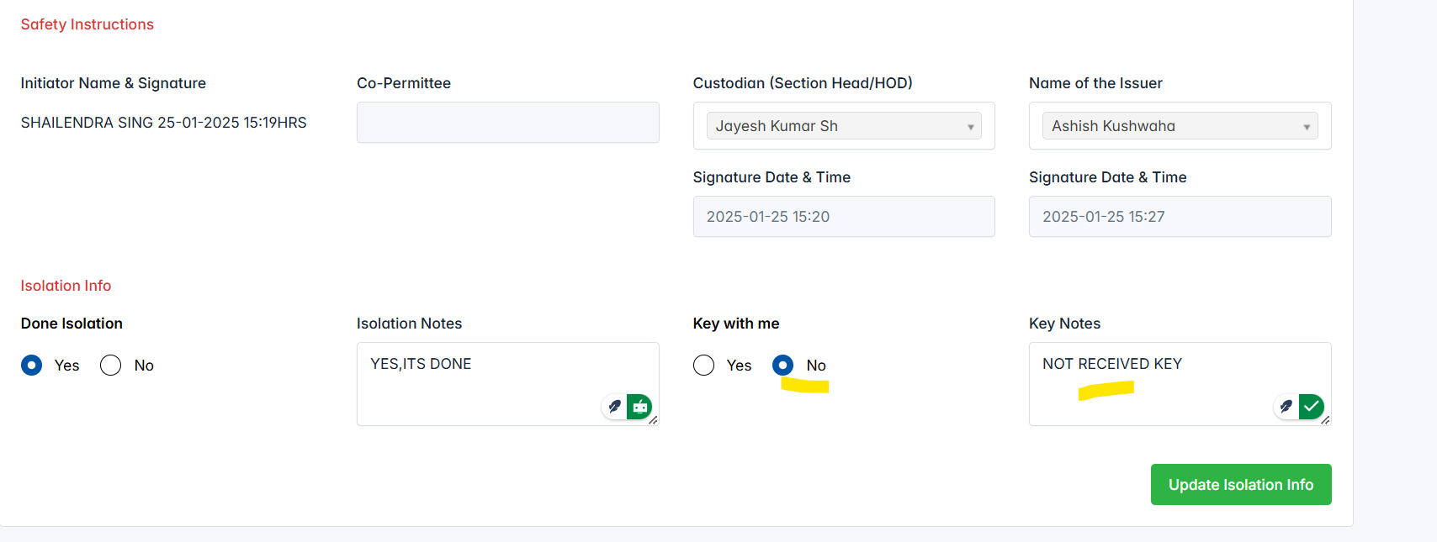

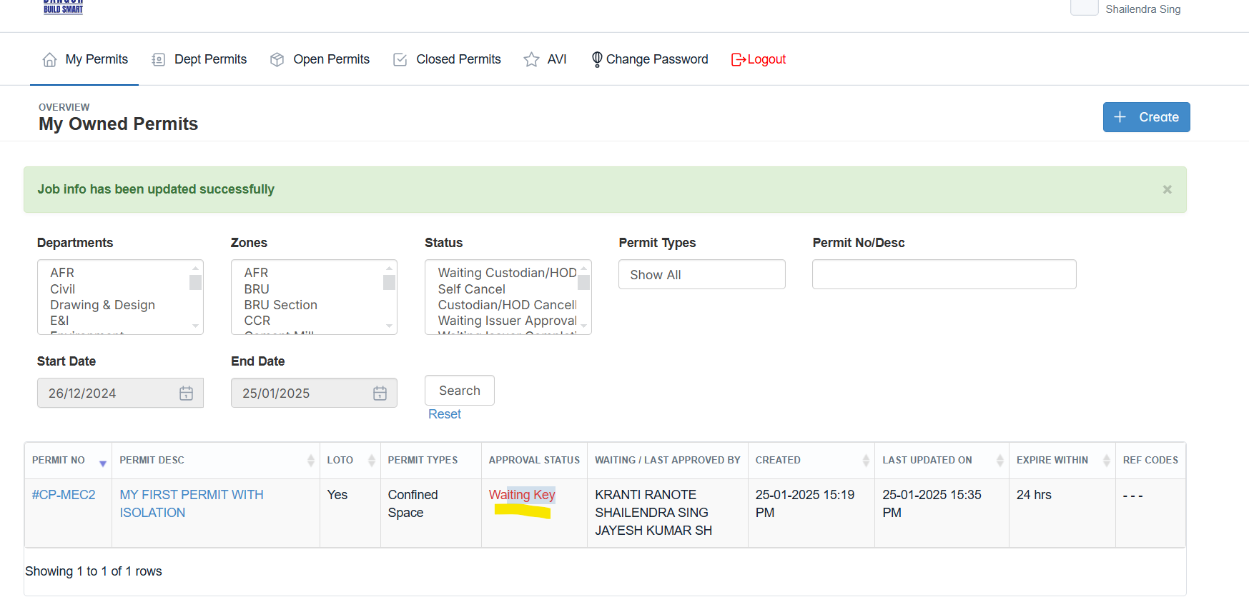

Once, they received key from isolators and mark key with me as “Yes”, then the permit start to move forward.

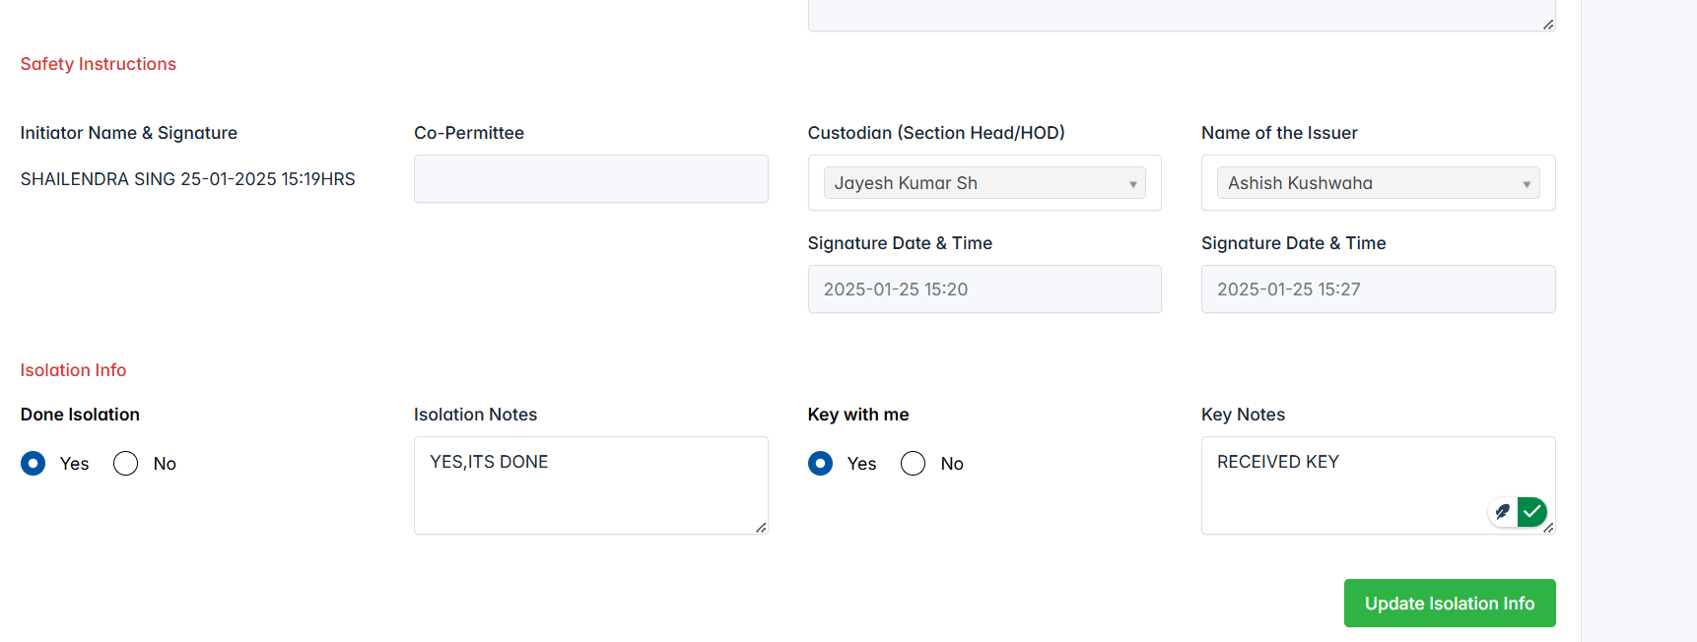

After marked as “Yes”, status will be changed to “Waiting Issuer Checkpoints updates”

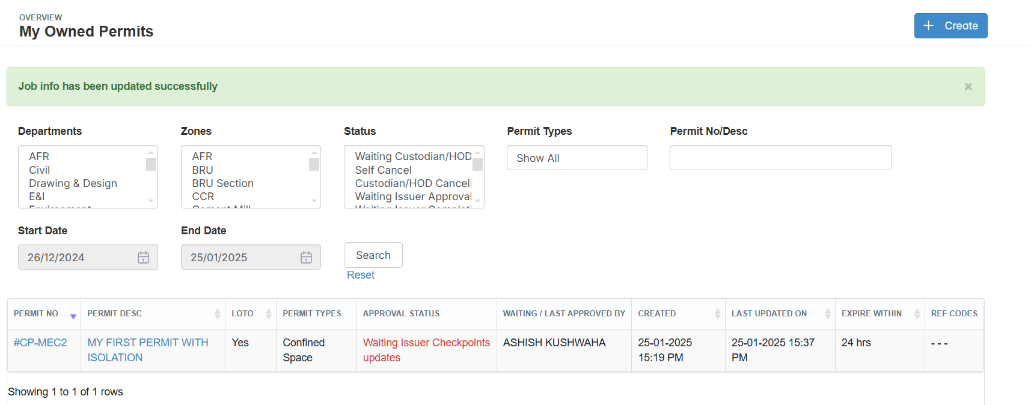

**Step6 Responsible Person : Issuer**

Logged as issuer and filled the checklists. Permit moved to “Final Submit”.

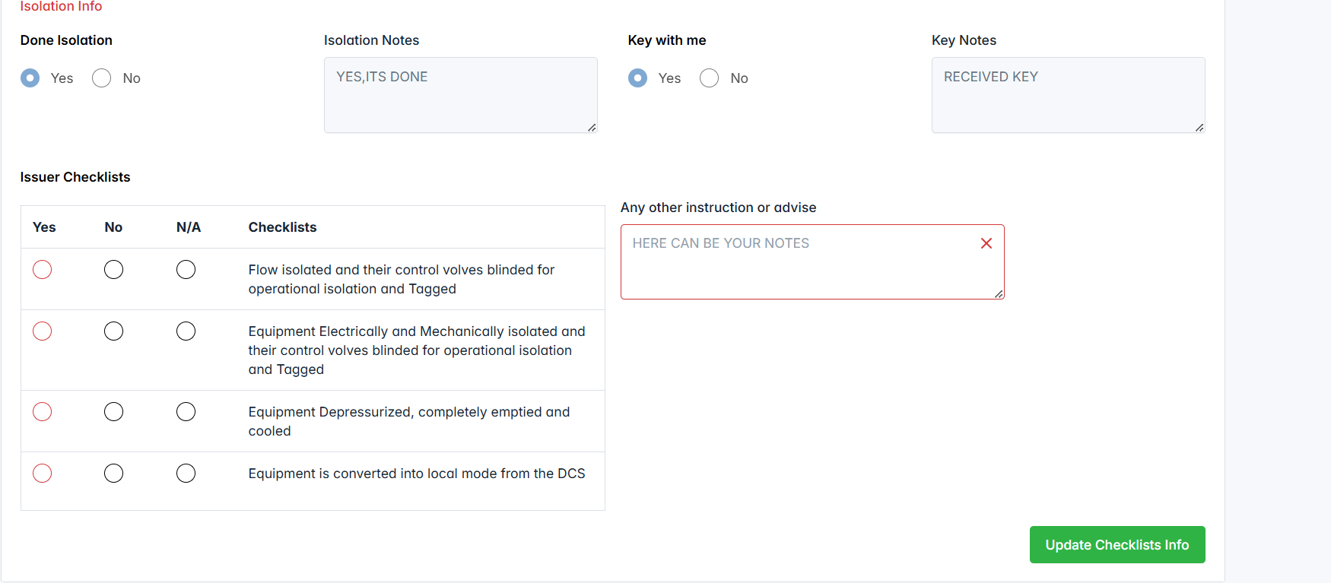

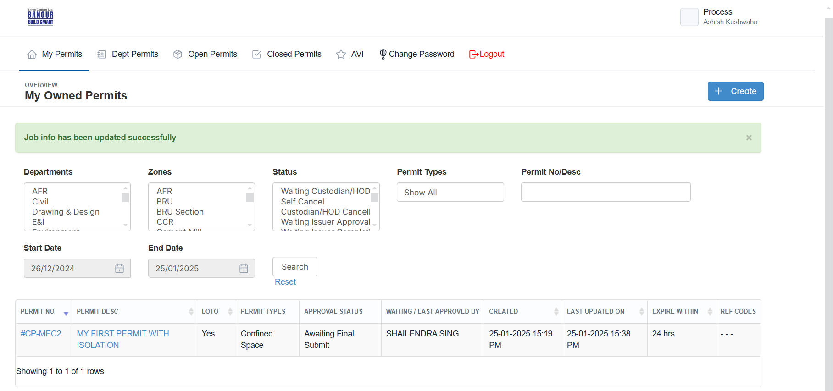

**Step7 Responsible Person : Initiator**

Once, the permit reach “Final Submit”, requestor can be the confirm that and start their works.

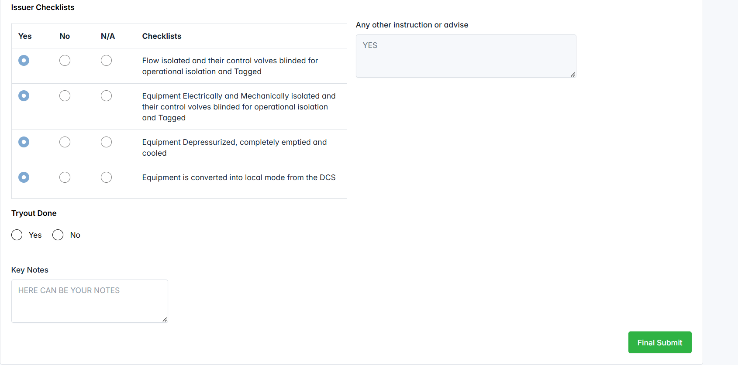

**Logged as “Initiator” and done the Final Submit. Now, the permit status is changed “In Progress”.**

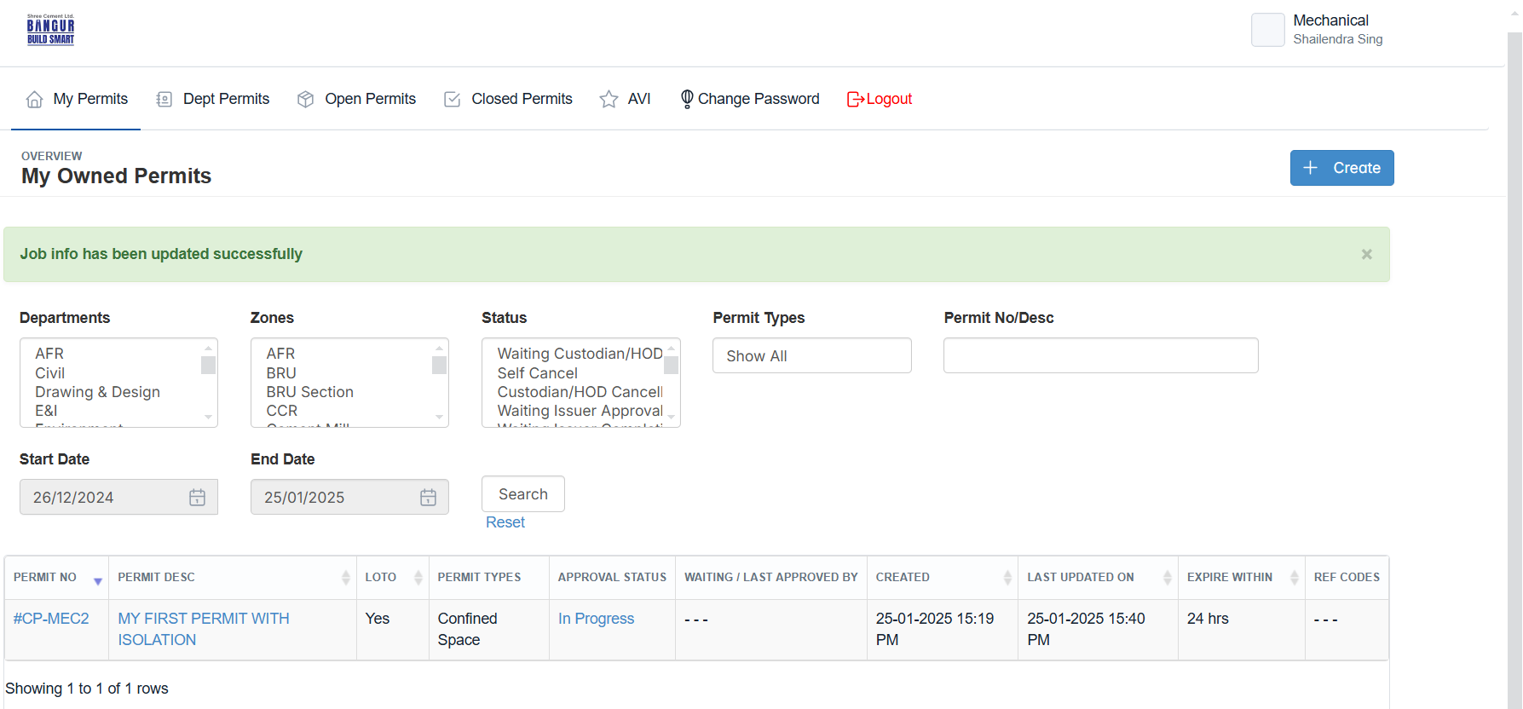

**Step8 Responsible Person : Initiator**

**From the "In Progress" stage, there are three options to move the permit forward.  
  
Completion –** This likely signifies that the permit is finished and can be finalized.

**Cancellation –** This option would stop the permit process entirely.

**Extension –** This allows for more time to work on the permit before moving forward.

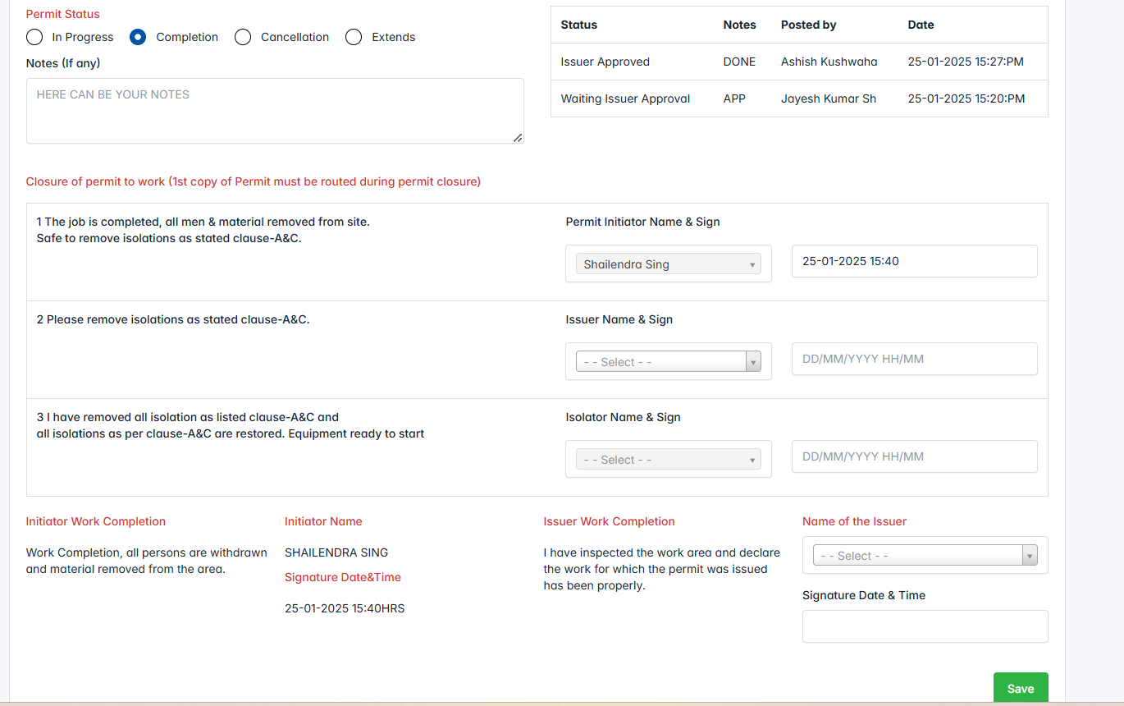

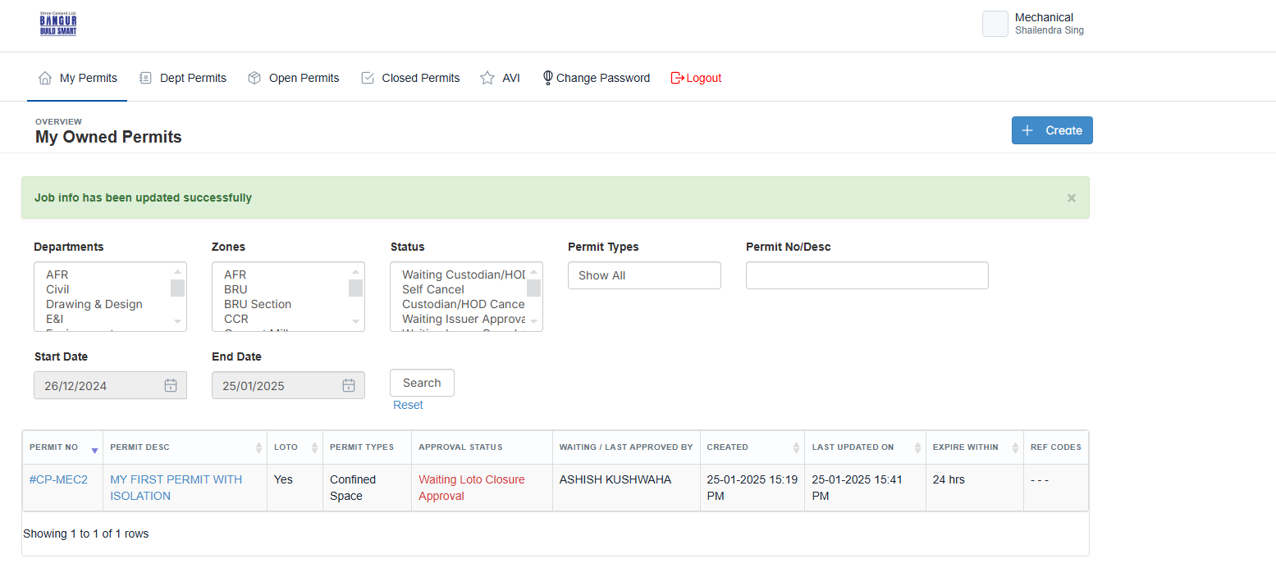

**Step9 Responsible Person : Issuer**

Logged as issuer to give approval close the permit and choose the isolator to confirm the energized the equipment.

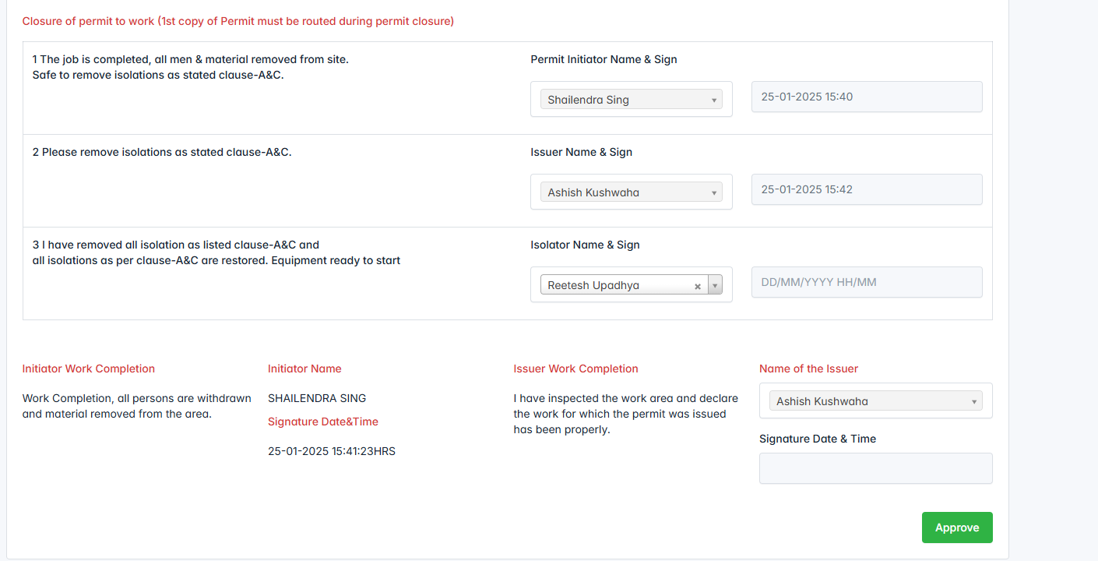

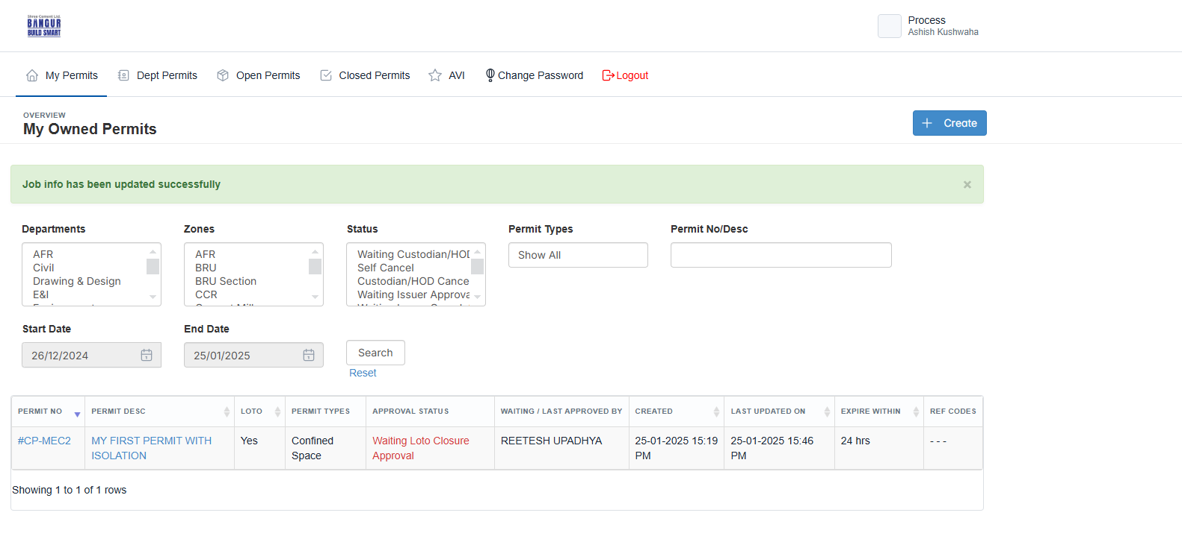

**Step10 Responsible Person : Isolator**

When you're logged as an isolator to confirm that the equipment is energized and to give approval for the permit to move forward, you're typically verifying the operational status of the equipment. Once, you confirmed permit status will be changed to “**Waiting Issuer Completion**”

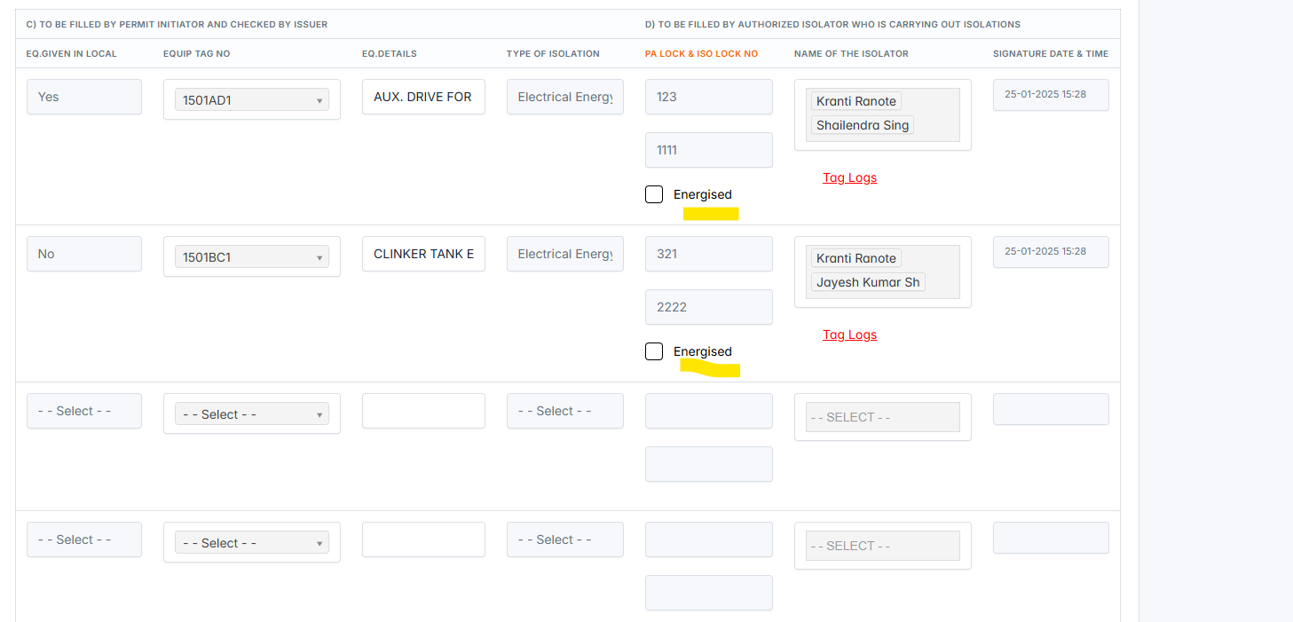

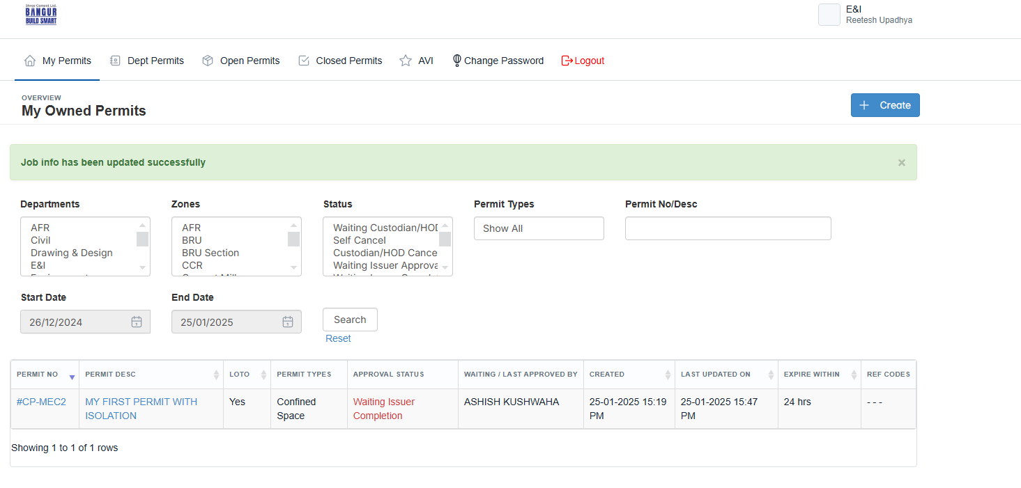

**Step10 Responsible Person : Issuer**

Logged as issuer to approve the Cancellation/Completion the permits requested by the requestors.

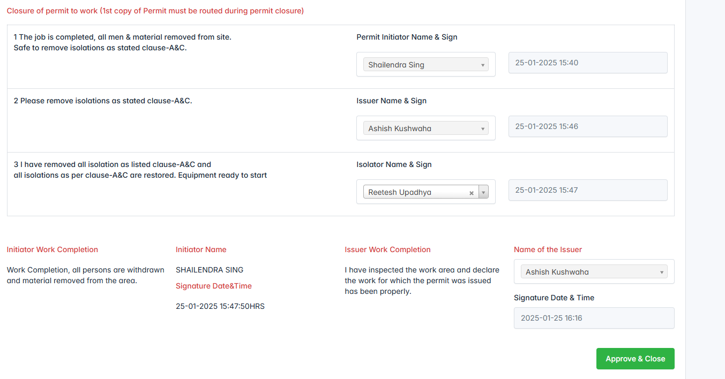

**That’s it. Now, the permit is completed and moved to “Closed Permit”.**

